# Unit testing

Within the strategy program, the unit is an individual prepare, work, and so on. By the way of the program, the least portion may be a way to incorporate a base/superclass. The unit test is a standard test computer program that analyzes the channel/portion of the research facility test.

|  |  |  |  |  |  |
| --- | --- | --- | --- | --- | --- |
| **Id** | **Title** | **Pre-Condition** | **Test Step** | **Actual Result** | **Excepted Result** |
| **1.1** | Add schedule of program name | Admin must be logged in the site | Fill-up field | Admin can add program name | Except |
| **1.2** | Add schedule of program dates | Admin must be logged in the site | Must be fill-up field | Admin can add program date and time | Except |

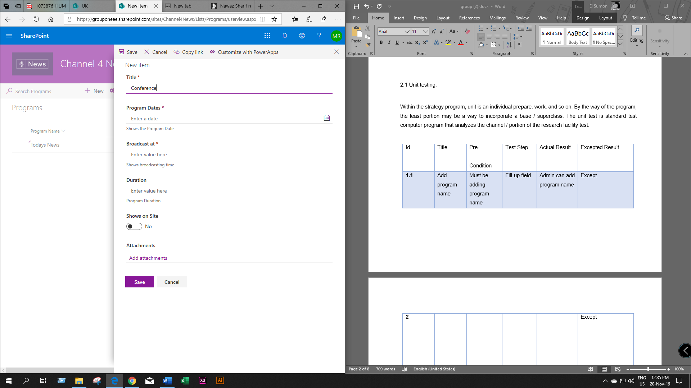

Figure : Add program name

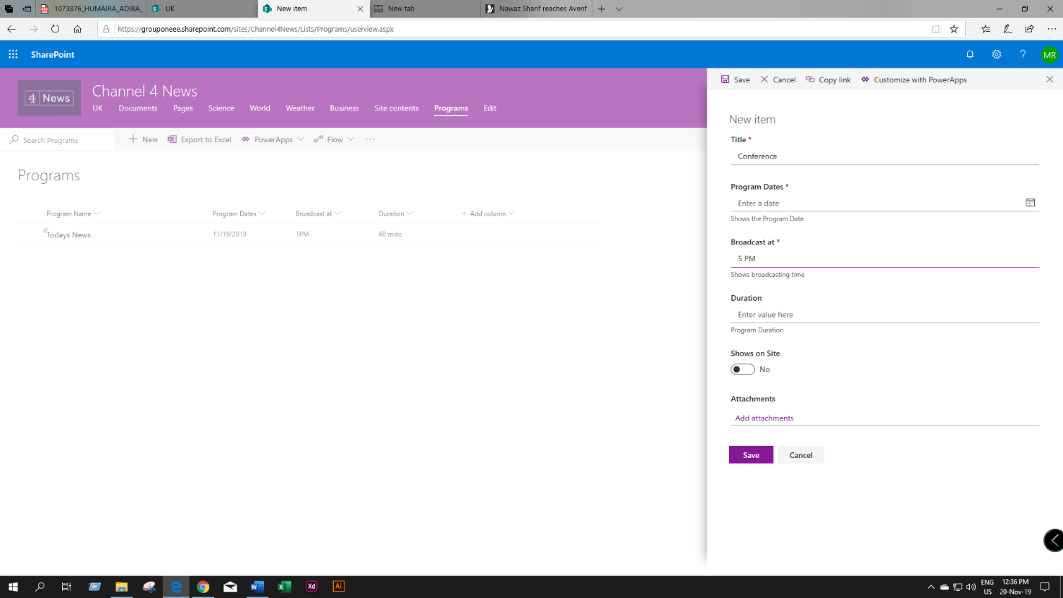

Figure : Add program date